Potatoes
Interesting Facts
It must be remembered that potatoes are half hardy and therefore can be damaged by frost and even cold easterly winds. The potato produces a crop by producing short rhizomes with stem tubers (potatoes) on the rhizomes.
It is common practice to use certified seed which are chitted especially for early production. The certified seed is actually selected small potatoes Stem Tubers) also known as seed potatoes. Chitted means that the buds on the seed potatoes have started to grow and therefore once planted will develop quickly.
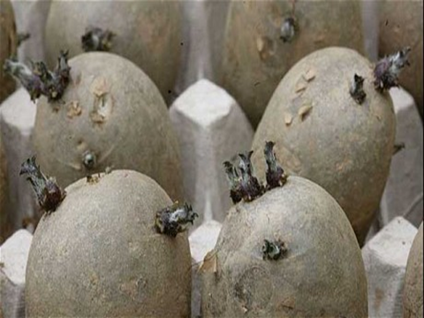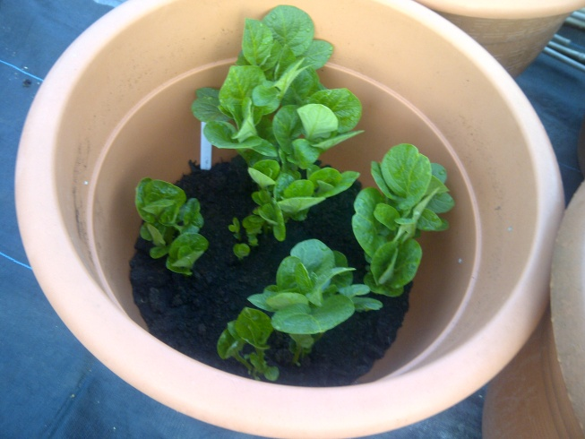
It is important to remember that potatoes obtained from a supermarket have most likely to have been cold stored, this will cause bud dormancy and therefore these potatoes are not suitable for use as seed potatoes.
Potatoes are suitable for most soil types, the aggressive root system and rhizome production will help to open up the soil especially a virgin plot. The foliage cover is almost 100% and this will therefore help to prevent weed growth, as it prevents light reaching the soil.
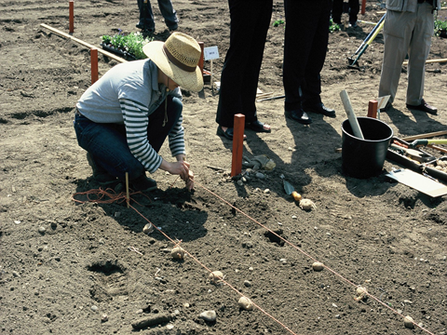
Potatoes are divided into the following groups:
- First early varieties. Plant in late March. Spacing 30 cm apart for the potato and 60 cm between the rows. 12 cm deep. Harvest in mid-June.
- Second early varieties. Plant in mid-April. Spacing 38 cm apart for the potato and 60 cm between the rows. Harvest in mid-July
- Main crop varieties. Plant in late April. Spacing 38 cm apart for the potato and 60 cm between the rows. Harvest in August.
It is a good practice to earth up around the haulm (this is the vegetative growth above the ground) when the growth is about 20 cm high. This will assist the development of the stem tubers.
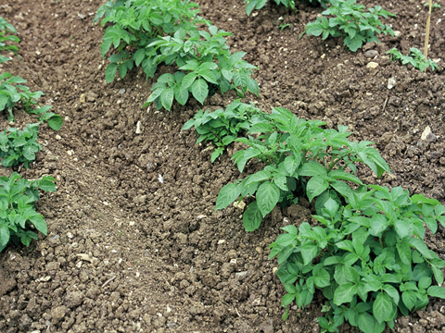
Do remember that potatoes enjoy an organic soil, so lots of organic matter should be added before planting. In addition a sunny position is best, never plant in the shade. Avoid chalky soil and certainly do not apply lime as this will encourage potato scab. If the soil is of low nutrition is important to add a general fertiliser.
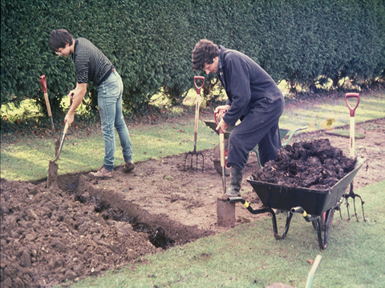

Potato problems
- Potato Scab:
- Leaf Roll Virus:
- Potato Scab:
- Frost:
- Slugs:
- Wire Worm:
- Potato Cyst Eelworm:
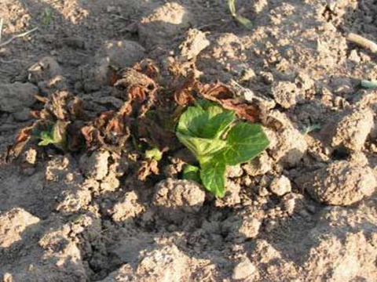 Frost Damage

Which varieties to choose?
This is a most difficult question as it depends on personal preference, however the following are examples of very reliable varieties:
- ARRAN PILOT, PENTLAND JAVELIN. These are first early varieties.

- WILJA, GREAT SCOTT. These are second early varieties.

- KING EDWARD, MAJESTIC. These are main crop varieties.

